Cody Pearson

THE JOURNEY SO FAR
BACKGROUND
Cody was referred to our service by his work coach Nadeem following his Universal Credit appointment. At the time, he was seeking support in finding employment but faced a number of barriers. Having moved to Pendle a couple of years earlier, Cody spent most of his time at home where he felt socially isolated and lacked opportunities to make new friends. He struggled with confidence, motivation, and the absence of a support network, all of which made it difficult for him to take steps towards his future goals.
SUPPORT RECEIVED
To help Cody overcome these challenges, we worked with him to develop a tailored support plan that would not only prepare him for work but also help him rebuild his confidence and reconnect with his community. This included a blend of physical activities, social opportunities, skills development, and practical experience. The aim was to gradually encourage Cody to step outside of his comfort zone, while equipping him with the tools and mindset needed to progress.
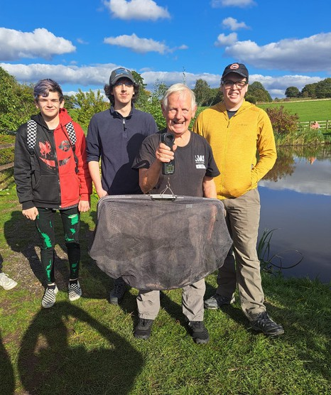
Cody began his journey by attending gym sessions in Pendle. This helped him to establish a healthier routine, improve his physical wellbeing, and gain confidence in a structured environment. He then joined Walk Wednesday, a weekly walking group which gave him the chance to meet new people in a relaxed and welcoming setting. These first steps were crucial in helping him feel more comfortable around others and begin building friendships.
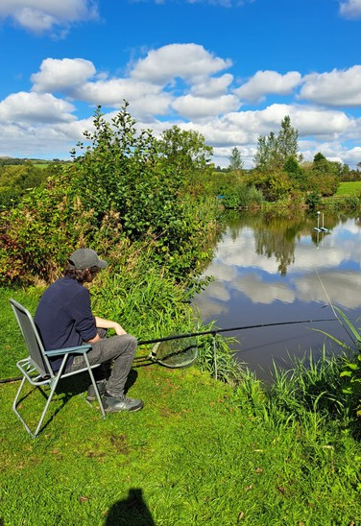
From there, Cody started taking part in a wider variety of activities that pushed him further outside of his comfort zone. He joined badminton sessions and enjoyed fishing at Cornfield Fisheries, both of which allowed him to socialise while learning new skills. He also attended an outdoor activity day at Pennine Oaks, where he tried archery, air rifle shooting, axe and knife throwing, and even carved his own pencil. These activities provided him with new challenges and the opportunity to work alongside others, all while strengthening his confidence. A particularly memorable experience for Cody was ghyll scrambling with Martin from Move2Change. This demanding outdoor activity gave him a real sense of achievement and further boosted his self-belief.
Alongside these recreational and confidence-building activities, Cody also focused on his personal development and employability. He successfully completed his Level 1 Health and Safety qualification online, demonstrating his commitment to improving his skills and building his CV. In addition, he took part in a three-week BAE Systems Business course in Preston, which included both classroom-based training and a one-week work placement with the Data Analytics Team. Cody also engaged in a voluntary scheme, supported by the DWP, that connects unemployed young people with structured work placements offered by major employers to build skills, confidence, and pathways into jobs, apprenticeships, or further training. This experience provided Cody with valuable insight into a professional workplace, as well as the opportunity to develop technical and transferable skills that will benefit him in his future career.
Through all of these activities and opportunities, Cody has made remarkable progress. He has gained confidence, built new friendships, and established a stronger sense of belonging in his community. He has developed practical and transferable skills through both recreational learning and structured training, and he now has valuable work experience and a recognised qualification to support his career aspirations. Most importantly, Cody has transitioned from feeling isolated and disengaged to becoming motivated, positive, and work- ready.

Cody’s journey highlights the importance of combining social, physical, and professional development opportunities when supporting individuals who face barriers to employment. By engaging in a wide range of activities, he has been able to rebuild his confidence, broaden his skills, and discover his potential. He now feels prepared and motivated to take his next steps into work, with a renewed sense of purpose and direction.

