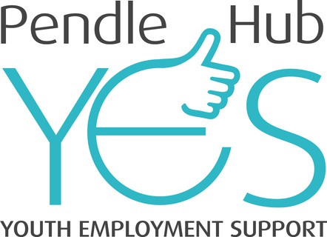

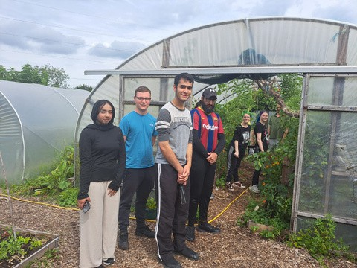
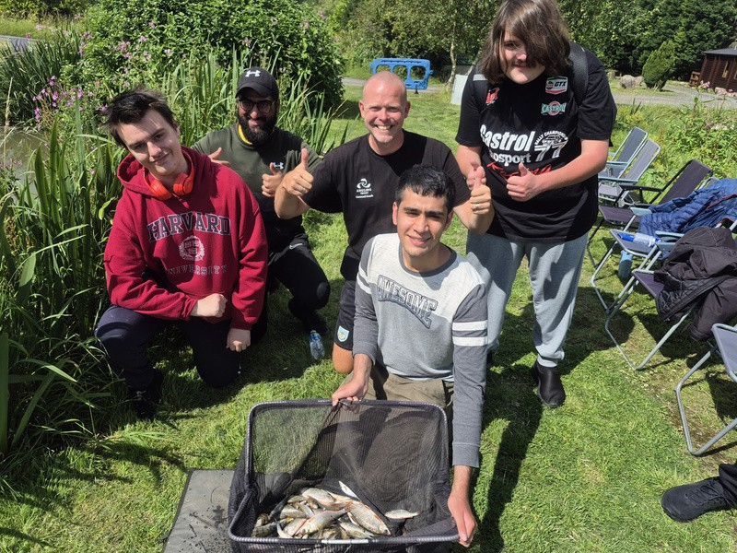
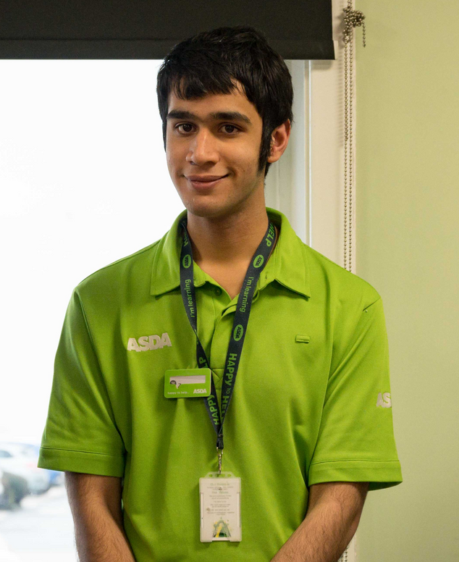
Zain Qureshi
THE JOURNEY SO FAR
BACKGROUND
Zain was referred to the YES Hub after completing a year-long Asda Supported Internship. The internship had given Zain a strong foundation of workplace experience, helping him to develop valuable skills such as teamwork, communication, and time management. While this experience provided a positive starting point, Zain needed continued support to build his confidence, broaden his social opportunities, and prepare for the transition into long-term employment.
SUPPORT RECEIVED
At the YES Hub, Zain engaged in a wide range of activities designed to strengthen both his personal and professional development. He began by taking part in recreational sessions at the Hub, where he enjoyed playing pool, table tennis, and FIFA. These activities provided him with a relaxed environment to meet new people, build social connections, and grow in confidence. They also helped him to develop teamwork and communication skills in an informal, enjoyable setting.
As his confidence increased, Zain began to take part in more challenging experiences. At Pennine Oaks in Barrowford, he embraced outdoor and creative activities such as axe throwing, air rifle shooting, archery, berry picking, and arts and crafts. These sessions encouraged Zain to step outside of his comfort zone, try new skills, and work alongside others. Each new activity gave him a sense of achievement and helped him realise his ability to adapt and succeed in different situations.
Zain also joined the Good Life Project, where he learned practical life skills in a supportive group setting. One highlight was making pizzas completely from scratch, which not only taught him about cooking and following instructions but also gave him a sense of independence and pride in his achievements.
Through this mix of recreational, outdoor, and skills-based opportunities, Zain developed greater confidence, resilience, and social skills. The combination of structured support and enjoyable activities allowed him to balance personal growth with employability preparation. He began to see how the skills he had built during his internship with Asda could be applied more widely, and he gained the motivation to continue working towards his career goals.
Today, Zain is more confident, socially connected, and now has gained employment with Asda. His journey shows how a combination of practical work experience, social engagement, and tailored support can help young people transition successfully from supported education into the world of work. The YES Hub has played an important role in helping Zain build on his achievements, discover new strengths, and move forward with a clearer sense of direction and purpose.

