Pendle Traffic Liaison Meeting
Monday 8th September 2025 at 14:30
Virtual – Microsoft Teams

Minutes

In Attendance:
Mark Whittle (chair) Lancashire County Council – Traffic and Safety
Usman Ahmed Lancashire County Council – Traffic and Safety
Janet Simpson Lancashire County Council – Development Control
Claire Garfield-Lane Lancashire County Council – Traffic Orders
Karen McAuley Lancashire County Council – Road Safety
Scott Whalley Pendle Borough Council
Gary Makin Lancashire Constabulary

- Apologies –
Matthew Hargreaves - Lancashire County Council – Traffic and Safety
Kelly Holt - Lancashire County Council – Development Control
Deborah Giles - Lancashire County Council – Traffic Orders
LCC Parking Service – currently no officer in post

- Agreement of previous minutes – No Comments

- Current TROs and SLOs

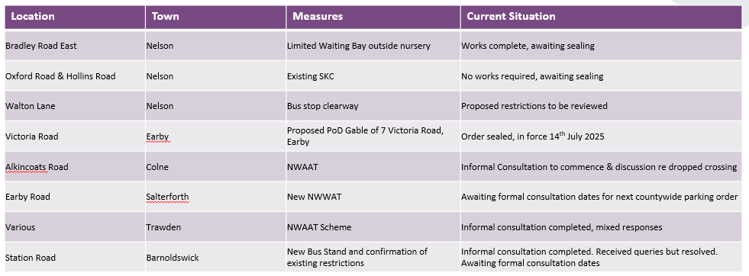

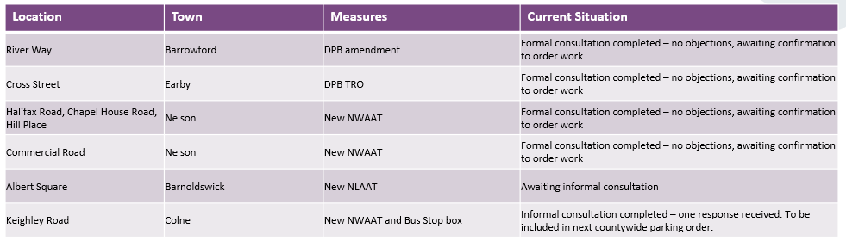

The proposals awaiting informal consultation will be completed, when possible, in line with current resource constraints and priorities. All in attendance were advised to contact MW if any of these proposals are required progression as a priority.

- Parking Concerns / Requests for Restrictions

  - Albert Street, Colne – parking issues for resident

Request received from a resident of Albert Road, Colne for restrictions on the frontage of block 40 to 59 to help with parking issues from local businesses.

KM raised a point if any site visits have been conducted? UA had conducted various site visits and seen that it has been parked up every time. KM added if a limited waiting and residents parking bay could be combined? MW added we would not support a resident parking bay on the main road as there are also businesses present, and it is a main road which isn't primarily residential. SW added there is a car park opposite the road outside Linden Business Centre. KM raised the question if residents from 49-59 can park in the residents parking down the side streets and if it was the same zone? MW made us aware the zones for parking permits are different. All in attendance agreed that LCC will proceed with informal consultation for limited waiting to gauge resident/business views.

  - Colne Road, Barrowford – parking in double white system

Issues with vehicles parking on/beyond the bridge towards the reservoir, forcing overtaking with reduced onward visibility.

GM made us aware if the lines were to be refreshed, then the police would be able to enforce only if several complains come through. SW commented he had not seen any issues regarding this proposal as he does travel through there. MW added that MH has seen this problem several times as he does travel through there quite often. All in attendance agreed that LCC will proceed with refreshing the lines and if the problem still occurs, we will then pass this onto the police where they can then enforce when resources allow.

  - Colne Road, Brierfield – limited waiting issues

The existing limited waiting bay outside 61-63 slightly goes over dropped kerbs. All LW bays in the area are signed as maximum stay of 1 hour but the legal order specifies 30 minutes. MW recommended shortening the bay before the dropped kerbs and amending the legal order to reflect the signs which have been in place since at least October 2008. All in attendance agreed that LCC will proceed with amending the order and lines on site to match.

  - Gibfield Road, Colne – school issues

Issues still reported by headmaster of John Fisher and Thomas More Secondary School.

MW suggested a proposal of loading restrictions on the single and double yellow lines to coincide with the existing waiting times, as well as a bus stand to allow any school buses to wait for more than 2 minutes. GM has no objections to extra parking enforcement going ahead. SW pointed out the worst parts are just before the bridge as it narrows and has no objections as this shows we are helping. KM raised the question if we have consulted with parking enforcement if they have reported any issues. MW confirmed that no comment could be provided at this time due to no person being in post for managing enforcement of this area. JS supported the proposed bus stand. SW suggested if the verges could be turned into parking spaces as MW stated we would not have the funding for a project as we have had many requests for the same thing elsewhere. All in attendance agreed that LCC will proceed with informal consultation.

  - Regent Street, Colne – DYL extension request

Request from Jewson for extension to existing double yellow lines due to parked cars causing access issues for their HGVs.

MW suggested extending the existing double yellow lines may be possible, but we have not seen any parked vehicles on or past these double yellow lines during site visits, therefore we would not pursue this at this time. GM suggested that the lines look faded by looking at the street view. MW added we would look to get the lines refreshed. All in attendance agreed that LCC will proceed with not inserting further DYL but to refresh the existing DYL where necessary.

  - Cuckstool Lane, Fence – H-bar request

Reported problems with vehicles parking on the dropped kerb.

Request for a H-bar to be placed on Cuckstool Lane to allow wheelchair users, strollers and walkers to use the dropped kerb on a daily basis. SW raised a suggestion of a pedestrian crossing. MW added a pedestrian crossing is not possible as there is no pavement opposite to the dropped kerb. JS raised a point how vehicles could be parked there due to an overflow of parking from the village hall. MW added there has not been any recorded injury collisions. All in attendance agreed that LCC will proceed with monitoring this location and may bring back to future TLMs if a problem emerges.

- Speed / Traffic Concerns

5.1 Various roads- request for traffic calming

Request for traffic calming measures from PC Bradley Wheeler for:
Cuckstool Lane, Fence
Halifax Road, Brierfield
Clitheroe Road, Brierfield (where it slows from national to 30mph over the M65 bridge)
Colne Road, Brierfield – full length
Manchester Road, Nelson – full length

SW mentioned there was not enough funding to support these projects and raised a question regarding the speed cameras to be implemented along Colne Road, Brierfield. GM confirmed there is no funding for additional camera schemes at this time.

- LCC Development Control

JS mentioned Colne Road limited waiting bay, but this matter was discussed in point 4.3.

- Pendle Borough Council items

  - Items from West Craven Committee 05.08.2025

- That the Bus Stand on Station Road be welcomed.

(2) That LCC be asked to reconsider removing the Disabled Parking Bay outside the Civic Hall and creating 2 spaces in front of the Station Road car park.
MW confirmed the carriageway is not wide enough given the proposed bus stand. LCC is not considering any additional on-street disabled parking provision given the existing provision on the civic hall car park, other nearby car parks and potential for 3-hour Blue Badge parking on yellow lines where safe to do so. SW – agrees.

- That LCC be asked to review the need for the Hackney carriage stand on Church Street, Barnoldswick.

- That the New No Waiting At Any Time TRO on Albert Square be supported but LCC be reminded that the street to the rear of Barnoldswick’s Town Square had never been called Albert Square and that the naming of streets was the responsibility of Ward Councillors.

(5) That LCC be asked to consider introducing a Vision Zero policy on road safety like the one in West Yorkshire

- Police Items

Nothing to report.

- LCC TRO Team

Nothing to report.

- LCC Road Safety

Nothing to report.

- LCC Parking Services

Nothing to report.

- Any Other Business

Nothing to report.

- Provisional date of next meeting

Last 2 weeks of November or first week of December 2025, ideally before 10th December.

