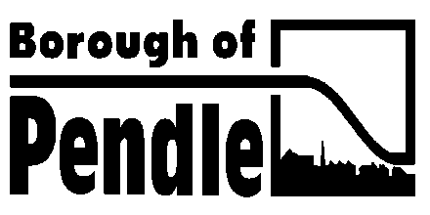
MEETING OF THE

NELSON TOWN DEAL
BOARD

TO BE HELD ON

FRIDAY 20TH NOVEMBER, 2020

AT 10.00a.m.

The meeting is being held remotely
on Microsoft Teams

PHILIP MOUSDALE, CORPORATE DIRECTOR

If you would like this information a way which is better for you, please telephone us.


A G E N D A

PART I – OPEN TO THE PUBLIC AND PRESS

1. Declarations of Interest

Members are reminded of the requirement to declare any interest they have on any item of business on the agenda.

2. Minutes

Enc. To approve the minutes of the meeting held on 23rd October 2020.

3. Developing the shortlisted projects – update on progress

To receive a presentation from Hatch on the progress of the project working groups.

4. Workplan Update

Enc. The attached report provides an update on progress against the workplan.

5. Any Other Business

6. Date of Next Meeting - 18th December 2020 at 10.00a.m.

7. Exclusion of the public and press

To consider excluding the public and press from the meeting during the next following item of business in pursuance of the power contained in Section 100(A)(4) of the Local Government Act, 1972 as amended when it is likely, in view of the nature of the proceedings or the business to be transacted, that there will be disclosure of exempt information which is of a commercially sensitive nature.

PART II – EXEMPT ITEMS

8. Accelerated Funding

A verbal update will be given at the meeting.

