Application Ref: 16/0722/FUL

Proposal: Full: Installation of a telecommunications mast comprising a 17.5m monopole supporting 3 antennas and 1 transmission dish, 3 equipment cabinets, 1.8m palisade fence and ancillary development.

At: Earby Cricket Club, William Street, Earby

On behalf of: CTIL And Vodafone Ltd

Date Registered: 18/10/2016

Expiry Date: 13/12/2016

Case Officer: Alex Cameron

Site Description and Proposal

The application site is an area of open land within the settlement boundary of Earby associated with Earby Cricket Club. The land is of no designation, it does not fall within the land of the cricket ground designated as Open Space. To the north are terraced houses, to the west is the cricket club building and terraced housing, to the south is a line of trees with the cricket ground beyond, and New Cut runs to the east with the former Brook Shed beyond, which falls within Earby Conservation Area.

The proposed development is the installation of a 17.5m tall telecommunications mast to provide improved mobile phone coverage to the area. The development also includes ancillary equipment cabinets and 1.8m palisade fenced compound.

Relevant Planning History

None.

Consultee Response

Natural England – No objection.

Arqiva – No observations.

NATS – No objection.

LCC Highways - The Highway Development Control Section does not have any objections in principle regarding the proposed installation of a telecommunications mast at the above location. We are of the opinion that the proposed development should have a negligible impact on highway safety and highway capacity in the immediate vicinity of the site, subject to the following comments being noted and condition being applied to any formal planning approval.

The applicant has indicated that the site will be accessed via Barret Street, although there would appear to be no vehicle entrance at this side of the cricket club. A more direct route would seem to be via Applegarth Street. However the applicant should ensure that any route chosen would be adequate for the type and number of construction/delivery vehicles going to and from the site.

Earby Town Council

Public Response

Site notices posted and nearest neighbours notified. Four responses received raising the following concerns:

In the document Supplementary Information 431230.PDF (page 4) It states that the construction will be more than 40 metres from the nearest residence. This statement is not true, it has been measured and is only 29 metres from the centre of the construction to the nearest residence, 26 Riverside Terrace and less than 40 metres from 27 Cowgill Street.

Health and safety concerns.

The mast should be sited on the other side of the field, away from houses.

Concerns about interference with appliances and television reception.

Noise and inconvenience during installation.
Views from adjacent houses would be dominated by the mast.

Loss of value of adjacent properties.

The mast would add to existing disturbance from the Cricket Club.

Officer Comments

Policy

Pendle Local Plan Part 1: Core Strategy

Policy ENV1 (Protecting and Enhancing Our Natural and Historic Environments) states that proposals in the designated open countryside should have regard to the Development in the Open Countryside SPG, or its replacement. In determining proposals which affect the Forest of Bowland Area of Outstanding Natural Beauty (AONB) great weight will be given to conserving its landscape and scenic beauty.

Policy ENV2 (Achieving Quality in Design and Conservation) states that all new development should viably seek to deliver the highest possible standards of design, in form and sustainability, and be designed to meet future demands whilst enhancing and conserving our heritage assets. Proposals should protect or enhance the natural environment and not detract from the natural beauty of the AONB by way of their siting, size, design and appearance.

Replacement Pendle Local Plan

Policy 38 (Telecommunications) of the Replacement Pendle Local Plan states that proposals for new telecommunications development should, in the first instance, seek to share an existing mast or site. All proposals should minimise the impact on the natural and built environment, designated areas, listed buildings, educational establishments and residential amenity. Design should be sympathetic in respect of height, materials and colours.

Applicants are also required to submit a statement which certifies that ICNIRP guidelines will be met.

Policy 38 is supported by the Adopted SPD: Guidelines for the Control of Telecommunications Equipment. In relation to development in urban area this sates:

"Telecommunications apparatus may be refused consent where they adversely affect the character and appearance of a listed building or its setting, or would be detrimental to amenity within conservation areas and other special areas. There should be no needless duplication. Development should be adequately distanced from residential properties. In any urban area, masts and antennae should be integrated into the townscape by utilising existing structures and buildings."

Guidance on telecommunications development is also contained within the National Planning Policy Framework paragraphs 42-46.

Paragraph 46 states that "local planning authorities must determine applications on planning grounds. They should not seek to prevent competition between different operators, question the need for the telecommunications system, or determine health safeguards if the proposal meets International Commission (ICNIRP) guidelines for public exposure."

Principle of the Development

The application has been accompanied by a statement which demonstrates that alternative sites have been considered and discounted. This acceptably demonstrates that no suitable alternative sites are available.

Concerns have been raised regarding the proximity of the proposed mast to dwellings, the nearest of which is approximately 35m from the proposed mast. National guidance is clear that, provided that a declaration has been provided that the proposal meets International Commission guidelines for public exposure, Local Planning authorities should not resist telecommunications applications on health grounds. An ICNIRP certificate declaring compliance with guidelines for public exposure has been submitted with the application and therefore the application is acceptable in terms of public health.

Therefore, the proposed development is acceptable in principle in accordance with policy 38 and paragraphs 42-46 of the Framework.

Visual Amenity and Heritage Impact

The proposed mast would be adjacent to existing developed area and tall vertical structures and features such as telegraph poles and set against a line of trees. Taking this into account, the mast and associated equipment compound would not result in an unacceptable impact upon the character or visual amenity of the area and would not harm the significance of the adjacent Conservation Area. The development is therefore in accordance with policies ENV1, ENV2 and 38.

Residential Amenity

The proposed mast would be a sufficient distance from nearby dwellings to ensure that it would not have an overbearing impact upon them or otherwise harm the amenity of residents. It is therefore acceptable in terms of residential amenity in accordance with policies ENV2 and 38.

Highway safety

The site is accessible from Barret Street and the proposed development is acceptable in terms of highway safety.

Other issues

Concerns have been raised regarding the potential impact on television signals and appliances. Arqiva, who are responsibility for UK broadcasting transmission facilities, have been consulted and have made no adverse comments.

Concerns have also been raised regarding loss of value of adjacent houses, impact on private views from dwellings and disturbance and anti-social behaviour resulting from the use of the Cricket Club. These are not matters that are material considerations or relevant to the determination of this planning application.

Reason for Decision

Section 38 of the Planning and Compulsory Purchase Act 2004 requires that applications be determined in accordance with the development plan unless material considerations indicate otherwise. The proposed development is acceptable in terms of policy, design, amenity and highway safety. The development therefore complies with the development plan. There is a positive presumption in favour of approving the development and there are no material reasons to object to the application.

RECOMMENDATION: Approve

Subject to the following conditions:

1. The proposed development hereby permitted shall be begun before the expiration of three years from the date of this permission.

Reason: Required to be imposed by Section 91 of the Town and Country Planning Act 1990, as amended by Section 51 of the Planning and Compulsory Purchase Act 2004.
2. The development hereby permitted shall be carried out in accordance with the following approved plans:

Reason: For the avoidance of doubt and in the interests of proper planning.

3. No development shall take place unless and until a construction method statement has been submitted to and approved in writing by the Local Planning Authority. The approved statement shall be adhered to throughout the construction period. It shall provide for:

i) The parking of vehicles of site operatives and visitors
ii) The loading and unloading of plant and materials
iii) The storage of plant and materials used in constructing the development
iv) The erection and maintenance of any security hoarding
v) Measures to control the emission of dust and dirt during construction
vi) A scheme for recycling/disposing of waste resulting from demolition and construction works
vii) Details of working hours
viii) Routing of delivery vehicles to/from site.

Reason: In the interest of highway safety

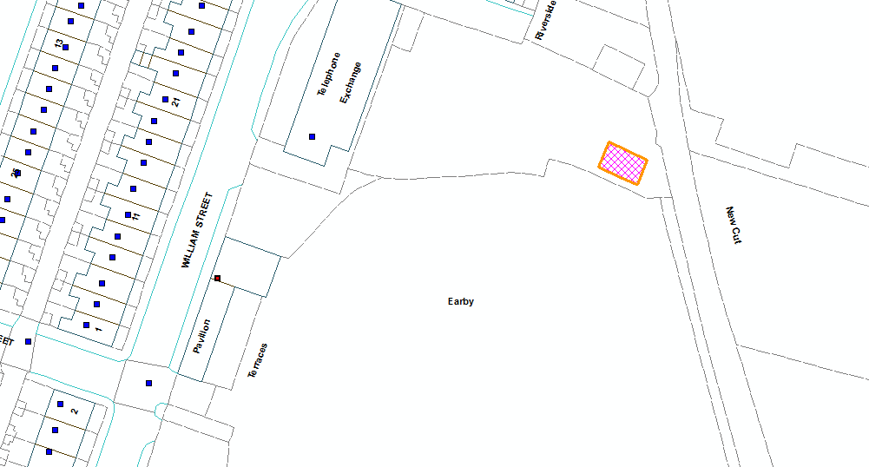

Application Ref: 16/0722/FUL

Proposal: Full: Installation of a telecommunications mast comprising a 17.5m monopole supporting 3 antennas and 1 transmission dish, 3 equipment cabinets, 1.8m palisade fence and ancillary development.

At: Earby Cricket Club, William Street, Earby

On behalf of: CTIL And Vodafone Ltd

