
WORKFORCE

REPORT

April 2025

- Introduction

This report gives information about the people we have recruited, the composition of the workforce and information about employees who have left the council based on information between 1st April 2024 and 31st March 2025

This information is based on current data in the HR & Payroll System. We have encouraged employees to access self-service to update personal details, therefore the accuracy of the data has improved. This is an ongoing process.

- Summary of Employees

- As at March 2025, Pendle Council employed 226 employees (FTE 212.27), of which 183 were full-time (81%) and 43 part-time (19%). Of the 226 employees, 85 (38%) were female and 141 (62%) were male.

- The average age of council employees is 48.

- 9.29% of employees are recorded as having a disability (compared to 9.85% when this was last reviewed in 2023-2024)

- 12% of employees are from an ethnic minority group (compared to 11.3% when this was last reviewed in 2023-24)

- The staff turnover for 2024-25 was 14.2% which equates to 32 leavers for the 12 months. This is down from the previous 12 months which was 15.2% turnover.

- Our Workforce

  - Employee Profile

    - Gender

We employ 85 females (38%) and 141 males (62%). This is very stable from the data last year.

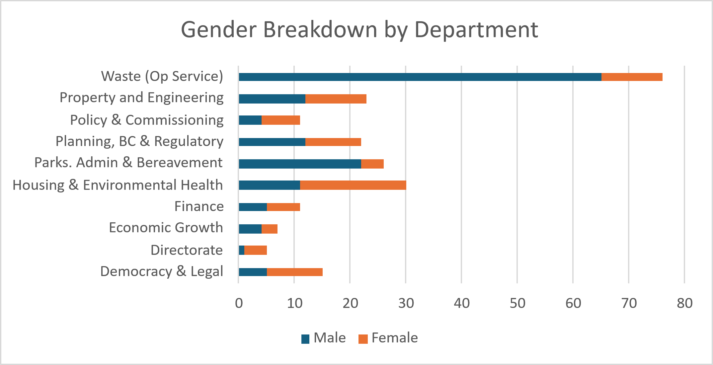

The table below shows the gender breakdown for part time employees and those on Management Grades, which we have defined as salary scales PO6 and above.

 | Total Staff | Male | Female | P/T Male | P/T Female | Male staff in management grades | Female staff in management grades
Total Work-force | 226
Total Work-force | 226 | 141 | 85 | 10 | 14 | 24 | 12
Total Work-force | 226 | 62% | 38% | 4.2% | 6.2% | 10.62% | 5.31%

Overall, departments mainly consist of full-time employees apart from Property which is due to cleaners and markets employees.

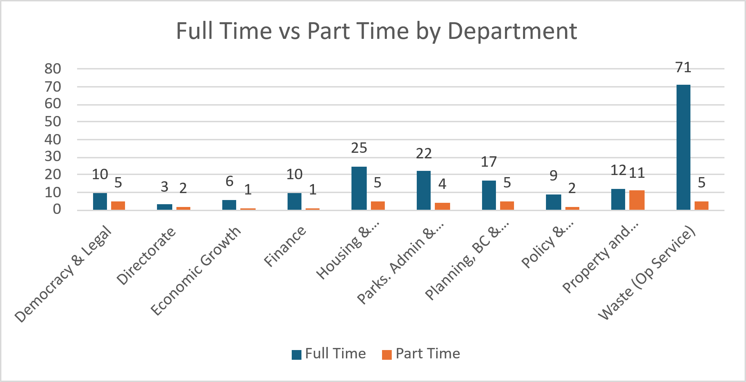

    - Ethnicity

The percentage of ethnic minority employees overall is 12% this is an increase on the last 2 years. However this is lower than the ethnic population within the district of 29.4% (2021 Census).

This is a positive step in the right direction with greater focus being given on representative selection panels and the recent recruitment and selection training carried out.

There are five (14%) employees from a minority ethnic community in senior management (PO6 and above).

    - Age

The age profile for employees is shown below.

Age | No of employees | Council 2024-25 | Council 2023-24 | Council  2022-23 | Council  2021-22
<25 | 10 | 4.88% | 4.4% | 6.4% | 2.4%
25 - 34 | 21 | 9.29% | 9.27% | 10.2% | 10.1%
35 - 44 | 50 | 22.12% | 24.4% | 22.9% | 25%
45 - 54 | 66 | 29.20% | 29.27% | 27.8% | 28.8%
55 - 64 | 66 | 29.20% | 29.27% | 30.2% | 28.8%
65+ | 13 | 5.75% | 3.41% | 2.4% | 4.8%

There is some positive movement in the table above with an increase in under 25’s. 64.2% of the workforce is 45 or over, with 35% being 55 or over.

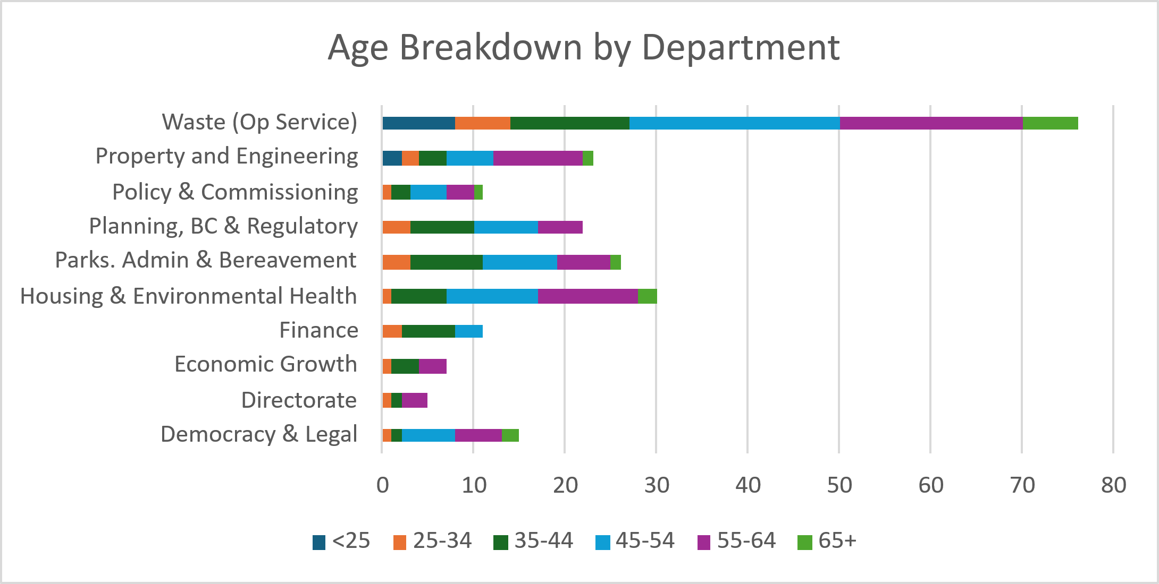

The age profile for Pendle Council generally reflects the profile for local government where there is a tendency to have a significant proportion of staff aged over 45 with long service however attention needs to be focused on succession planning with 35% of the total workforce aged 55 or over to ensure stability.

    - Disability

9.29% of employees declare themselves as having a disability compared to 11.3% last year. This figure has decreased and is potentially linked to a number of retirements. As with a small workforce figures can vary with only small changes in employees.

    - Other

We have no meaningful data on gender reassignment, pregnancy and maternity, marriage and civil partnership to report on.

  - Pay

The percentage of women in the top 5% of earners is 36%, this is stable from last year although there have been changes at the senior level.

We have 1 ethnic minority employee among our top 5% of earners.

Ethnicity of Management Grades – Key Statistics

White & White Other representation in management grades = 33 (91.7%)
Ethnic minorities represented in the management grades = 3 (8.3%)
Female ethnic minorities represented in the management grades = 0 (0.0%)
Male ethnic minorities representation in the management grades = 3 (8.3%)

Equality Workforce profile by pay bands as at March 2024

Salary Band | Ethnic Minority  (both M&F) | Disability  (both M&F) | Female | Average Age  (mean)  (both M&F) | Total number  in group  (both M&F)
Senior Management (Top 5%) | 5 | 1 | 7 | 53 | 22
PO 6-9 | 4 | 1 | 10 | 50 | 14
SO2 - PO5 | 5 | 6 | 10 | 50 | 29
Scale 4 – SO1 | 15 | 11 | 51 | 47 | 153
Scale 1 - 3 | 3 | 2 | 7 | 40 | 8

- Leaving the Council

  - Turnover
Turnover for 2024-25 was 14.2% with 32 leavers overall. This is up from last year when 31 employees left.

Reason for Leaving | Number of Leavers 2024-25 |  | Number of Leavers 2023-24 | % | Number of Leavers 2022-23 | %
Resignation | 21 | 66% | 16 | 52% | 24 | 63%
Retirement | 5 | 16% | 6 | 19% | 4 | 10.5%
Dismissal | 2 | 6% | 3 | 10% | 1 | 2.75%
Redundancy/Efficiency |  |  |  |  | 0
End of Contract | 1 | 3% | 5 | 16% | 8 | 21%
Ill Health Retirement |  |  |  |  | 0
Other | 3 | 9% | 1 | 3% | 1 | 2.75%
Total | 32 |  | 31 |  | 38

  - Departmental Attrition
As shown in the below table, attrition per department varies however, what must be considered is the size of the teams. A smaller team will show a higher percentage. The council overall attrition reads as 14.2% which is around the average mark for local government organisations.

Service Area | Leavers 2024-25 | Ave. Attrition Per Dep
Democratic and Legal | 4 | 21%
Directorate | 1 | 20%
Economic Growth | 1 | 12.5%
Finance | 1 | 8%
Housing and Environmental Health | 7 | 18%
Parks, Admin and Bereavement | 3 | 13%
Planning, Building Control and Regulatory | 3 | 13.5%
Policy and Commission | 3 | 27%
Property and Engineering | 2 | 6.5%
Waste (Op Services) | 7 | 8%

  - Reasons for Leaving
The most common reason for leaving being resignation. An online exit interview form is sent out to all leavers however, out of 32 leavers, only 3 of them gave feedback via the form (please see Appendix 1). In order to gain a better understanding and deeper analysis of exit reasons, the HR team are now considering reverting back to “In-person” exit interviews.

- Recruitment

There were 28 advertisements for 51 positions during this period. 184 people applied and 42 people have been appointed. The breakdown of applicants by equality group is detailed below.

  - Gender

Gender | Applied
Gender | Numbers | Percentage
Male | 102 | 55%
Female | 75 | 40%
Prefer not to answer | 7 | 5%
Total | 184 | 100.0%

  - Ethnicity

Ethnicity | Applied
Ethnicity | Numbers | Percentage
White – British | 112 | 61%
White – Irish | 0 | 0
White – Other | 8 | 4%
Mixed Race – White / Black Caribbean | 0 | 0
Mixed Race – White / Black African | 0 | 0
Mixed Race – White / Asian | 2 | 1%
Mixed Race – White / Pakistani / Other | 1 | 1%
Asian or Asian British – Indian | 4 | 2%
Asian or Asian British – Pakistani | 32 | 17%
Asian or Asian British – Bangladeshi | 2 | 1%
Asian or Asian British – Kashmiri | 0 | 0
Asian or Asian British – Other | 2 | 1%
Black or Black British - Caribbean | 0 | 0
Black or Black British - African | 4 | 2%
Black or Black British – Other | 1 | 1%
Chinese | 0 | 0
Other | 1 | 1%
Prefer not to answer | 15 | 8%
Total | 184 | 100.0%

Traditionally, front-line public-sector professions do not attract applicants from ethnic minority communities, however support services and administration type roles do. 7 out of 28 (25%) roles advertised this year have been front line positions.

According to 2021 figures (lancashire.gov.uk, n.d.), 29.4% of residents of Pendle identify their ethnicity as ‘other than white’. Our applicant statistics do closely match the applicant data.

  - Disability

Disability Status | Applied
Disability Status | Numbers | Percentage
Not Disabled | 166 | 90%
Disabled | 8 | 1%
Prefer not to answer | 10 | 9%
Total | 184 | 100.0%

The Council uses the “Disability Confident” committed symbol for recruitment, to show that we have measures in place to support the recruitment and employment of people with disabilities, and we are a Mindful Employer.

  - Age

Age | Applied
Age | Numbers | Percentage
<25 | 34 | 18
25 - 34 | 31 | 17
35 - 44 | 51 | 28
45 - 54 | 41 | 23
55 - 64 | 18 | 8
65+ | 1 | 1
Prefer not to answer | 8 | 5
Total | 184 | 100.0%

  - Sexual Orientation

Sexual Orientation | Applied
Sexual Orientation | Numbers | Percentage
Heterosexual | 150 | 81%
Bisexual | 3 | 2%
Gay Male | 1 | 1%
Lesbian | 3 | 2%
Prefer not to answer | 27 | 14%
Total | 184 | 100.0%

Appendix 1

            - Exit Questionnaires

