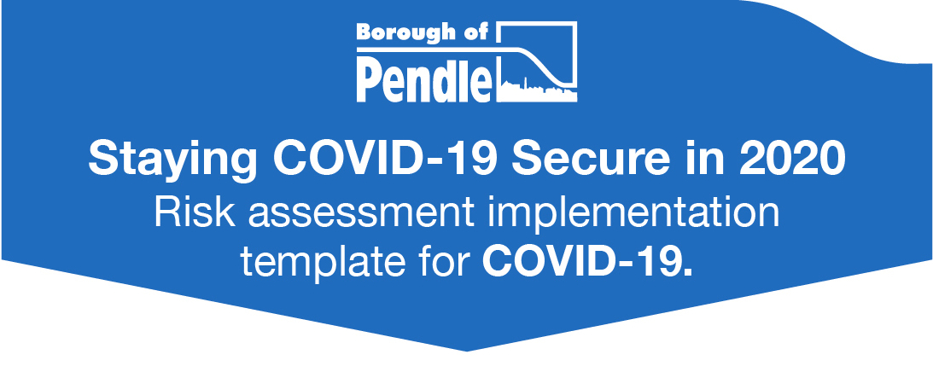

This template has been developed to help businesses implement the government COVID- 19 Secure guidelines issued on 25 May 2020.
This is particularly aimed at smaller, lower risk businesses that don’t have dedicated health and safety advice. Currently the guidance consists of 5 key points
Nothing in this document should add or take away from the guidance, and you don’t have to use this template to complete your risk assessment. We’ve created this to help you go through the risk assessment process and document your findings. This document can be freely copied and used but it is best to complete it on the computer as the boxes expand.
We take no responsibility for your risk assessment but we hope this helps you to get back to work safely.
- Think about your procedure for dealing with actual COVID-19 sickness
- Complete the boxes - the basic risk assessment
- Implement all the measures and check they work
- Save or upload risk assessment to website, print out notice, sign and display.

Business name and address:

Person carrying out risk assessment:

Signed and dated (when completed):

Be clear on your procedure on COVID-19 sickness
What arrangements will you put in place for sending people home if an employee or customer is displaying symptoms of COVID-19?

Any further cleaning or other actions that you would take to if this happens?

What will you do if an employee informs you that members of his/her household are displaying symptoms of COVID-19?

All employers must carry out a COVID-19 risk assessment
Key Point 1 - Work from home, if you can
All reasonable steps should be taken by employers to help people work from home. But for those who cannot work from home and whose workplace has not been told to close, our message is clear: you should go to work. Staff should speak to their employer about when their workplace will open.
Take all reasonable steps for people to work from home | Steps to take
Everyone should work from home, unless they cannot work from home. Nobody should go to work if your business is closed under the current Government regulations. | - Consider who is essential to be on the premises.  - Plan for the minimum number of people needed on site to operate safely and effectively.  - Clinically extreme vulnerable individuals are strongly advised not to work outside of the home.  - Clinically vulnerable individuals who are at higher risk of severe illness, have been asked to take extra care in social distancing and should be helped to work from home in their current or alternative role.  - Where the individuals above cannot work from home, they shall be offered the safest available on site roles, enabling them to stay 2m away from others. If they have to spend time within 2m of others, you should carefully assess whether this involves an acceptable level of risk.
Which employees are able to work from home?

If your workplace has not been told to close, when do you plan to open?

How have you communicated with staff about this?

Key Point 2 - Carry out a COVID-19 risk assessment, in consultation with workers or trade unions
This guidance operates within current health and safety employment and equalities legislation and employers will need to carry out COVID-19 risk assessments in consultation with their workers or trade unions, to establish what guidelines to put in place. If possible, employers should publish the results of their risk assessments on their website and we expect all businesses with over 50 employees to do so.

That all employers carry out a COVID-19 Risk Assessment | Steps to take
Employers have a legal responsibility to protect workers and the public for risks to their health and safety. This means you need to think about risks they face and do everything reasonably practicable to minimise the risks of COVID-19 for your business. The use of current Government guidance to inform your decisions, as well as your findings will determine the controls measures as part of your risk assessment. The risk assessment will also help you to decide whether you have done everything you need to do.  Where a business employs more than five people the findings of the risk assessment shall be recorded. | - Follow the key points within this document.  - Increase the frequency of hand washing and surface cleaning.  - Keep the activity time involved as short as possible.  - Use screens or barriers to separate people from each other.  - Use back to back or side to side working (rather than face to face) whenever possible.  - Reduce the number of people each person has contact with by using ‘fixed teams’ or partnering’ (so each person works with only a few others)  - If people must work face to face for sustained periods with more than a small group of fixed partners, then you will need to assess whether the activity can safely go ahead. No one is obliged to work in an unsafe environment.  - Your assessment should include whether people doing the work are especially vulnerable to COVID-19  - For further information about re-opening your business is available here
What consultation with workers or trade unions will you do?

Will you publish the results of your risk assessment on your website?

Key Point 3 - Maintain 2 metres social distancing, wherever possible
Employers should re-design workspaces to maintain 2 metre distances between people by staggering start times, creating one way walk-throughs, opening more entrances and exits, or changing seating layouts in break rooms.

Take all reasonable steps to maintain a 2m distance in the workplace | Steps to be taken
Maintain 2m social distancing wherever possible including while arriving at and departing from work, while in work while in work and travelling between sites.  Social distancing applies to all parts of the business, not just the place where people spend more time, but also entrances and exits, break rooms, canteens and similar settings. | - You must maintain social distancing in the workplace wherever possible.  - Where social distancing guidelines cannot be met in relation to a particular activity, business should consider whether the activity needs to continue for the business to operate. If so, take all the mitigating actions possible to reduce the risk of transmission between their staff.  - Consider increasing the frequency of hand washing and surface cleaning  - Keep the activity time as short as possible- consider shortening opening hours  - Use screens or barriers to separate people from each other  - Using back to back or side to side working (rather than face to face wherever possible)  - Reducing the number of people each person has contact with by using ‘fixed teams or partnering’ (so each person works with a few others).
This business will maintain 2 metre distances between people by:

Social Distancing - on arrival and departure and enable hand-washing on arrival

Maintain social distancing wherever possible, on arrival and departure and enable hand-washing on arrival. | Steps to be taken
Social distancing on arrival, departure and hand washing. | - Stagger arrival and departure times at work to reduce crowding into and out of the workplace, taking into account of impact on those with protected characteristics.  - Provide additional parking or facilities such as bike-racks, to help people walk, run or cycle to work where possible.  - Limit passengers in corporate vehicles for example, work minibuses.  - Reduce congestion by having more entry to points to workplaces in larger stores.  - Use markings and introducing one-way flow at entry and exit points.  - Provide hand washing facilities (or hand sanistiers where not possible) at entry and exit points.  - Provide alternatives to touch based security devices such as key pads.  - Define process alternatives for entry/exit points where appropriate for example, deactivating pass readers at turnstiles in favour of showing a pass to security personnel at a distance.
This business will maintain 2 metre distances between people by:

Social distancing - traveling through the workplace

Maintain social distancing as far as possible while people travel through the workplace | Steps to be taken
Social distancing and travelling throughout the business. | - Discourage non-essential trips in the building and sites, for example restricting access to some areas.  - Introduce a one way flow through the buildings.  - Providing floor markings and signage should remind both customers and workers to follow social distancing where possible.  - Reduce maximum occupancy for lifts, providing hand sanitiser for the operation of lifts and encouraging use of stairs wherever possible.  - Regulate use of high traffic areas including corridors, lifts, turnstiles and walkways to maintain social distancing.
This business will maintain 2 metre distances between people by:

 | Social distancing - workplaces/workstations
Social distancing workplaces/workstations | Steps to be taken
To maintain social distancing between individuals when they are at their workstations. | - For people who work in one place, workstations should allow them to maintain social distancing wherever possible.  - Workstations should be assigned to an individual as much as possible. If they need to be shared, they should be shared with the smallest possible number of people.  - If it is not possible to keep workstations 2m apart then businesses should consider whether the activity needs to continue for the business to operate, and if so take all mitigating actions possible to reduce the risk of transmission.  - Review layouts to allow workers to work further apart from each other.  - Use floor tape or paint to mark areas to help people keep at a 2m distance.  - Avoid people working face to face. For example, by working side by side or facing away from each other.  - Use screens to create a physical barrier between people  - Use consistent paring system if people have to work in close proximity. For example, maintenance activities which cannot be redesigned.  - Minimise contact around transactions, for example contactless payments.  - Rethink demonstrations and promotions to minimise direct contact and to maintain social distancing.  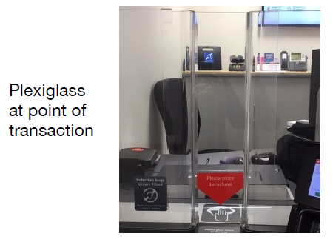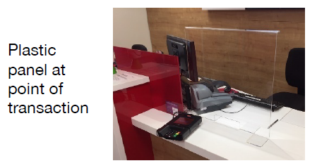
This business will maintain 2 metre distances between people by:

Social distancing - during meetings

Meetings | Steps to be taken
Reduce transmission due to face to face meetings and maintain social distancing in meetings. | - Use remote working tools to avoid in person meetings  - Only participants who are absolutely necessary should attend meetings and should maintain 2m separation throughout.  - Avoid transmission during meetings, for example avoid sharing pens and other objects  - Provide hand sanitiser in meeting rooms  - Hold meetings outdoors in well ventilated rooms whenever possible  - For areas where meetings regularly take place, use floor signage to help people maintain social distancing.
This business will maintain 2 metre distances between people by:

Social distancing - common areas

Common Areas | Steps to be taken
Maintain social distancing while using common areas. | • Stagger break time to reduce pressure on staff break rooms or places to eat  • Use safe outside areas for breaks  • Create additional space or other parts of the working area or the building that have been freed up by remote working  • Install screens to protect workers in receptions or similar areas.  • Provide packaged meals or similar to avoid fully opening canteens.  • Reconfigure seating and tables to optimise spacing and reduce fact to face actions  • Encourage workers to remain on site and, when not possible, maintaining social distancing while off site  • Consider using social distance marking for other common areas such as toilets, showers, lockers, and changing rooms and in other areas where queues typically form.
This business will maintain 2 metre distances between people by:

Social distancing - accidents, security and other incidents

Accidents, security and other incidents | Steps to be taken
Prioritise safety during incidents | - In an emergency, for example an accident, giving first aid, fire or a break in, people do not have to stay 2m apart if it would be unsafe  - People involved in helping others should pay particular attention to sanitation measures immediately afterwards including washing of hands.  - Review your incident and emergency procedures to ensure they reflect social distancing principles as far as possible.
This business will maintain 2 metre distances between people by:

Social Distancing managing customers

Managing customers | Steps to be taken
Minimise contact resulting from visits to stores or outlets.  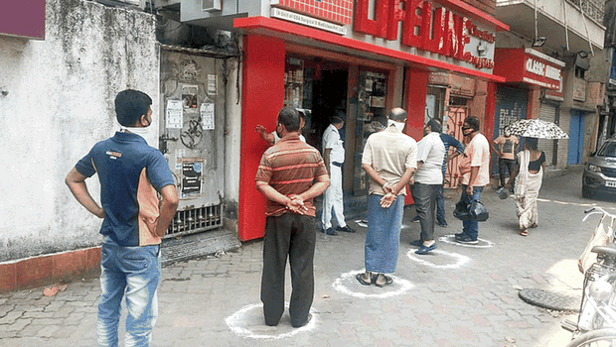  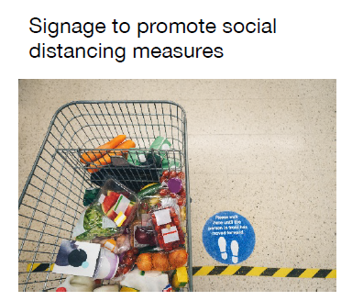  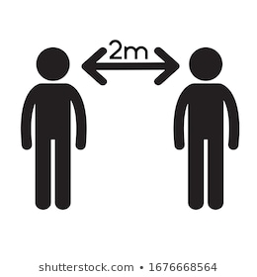 | - Define the number of customers that can reasonably follow 2m social distancing within store and any outdoor selling areas.  - Limit the number of customers in the store, overall and in particular, congestion areas for example, doorways, bottle necks, between outside and inside spaces.  - Encourage customers to use hand sanitiser or hand washing facilities as they enter the premises to reduce the risk of transmission by touching products whilst browsing.  - Encourage customers to avoid handling products while browsing if at all possible.  - Suspend or reducing customer services that cannot be undertaken without contravening social distancing guidelines. This may include re-thinking how assistance is provided, for example using fixed pair of colleagues to lift heavy objects rather than a single colleague lifting with a customer.  - Encourage customers to shop alone where possible, unless need for specific assistance.  - Remind customers who are accompanied with children that they are responsible for supervising them at all times and should follow social distancing guidelines.  - Look how people walk through the shop and how you could adjust this to reduce congestion and contact between customers for example, queue management or one way flow, where possible.  - Ensure any changes to entrances, exits, queue management take into account reasonable adjustments for those who need them including disabled shoppers.  - Provide additional parking or facilities such as bikes racks, where possible to help customers avoid using public transport  - Use outside premises for queuing where available and safe.  - Manage outside queues whilst keeping 2m distance and not causing a risk to individuals, other businesses, for example introduce a queuing system, using barriers and have staff direct customers.  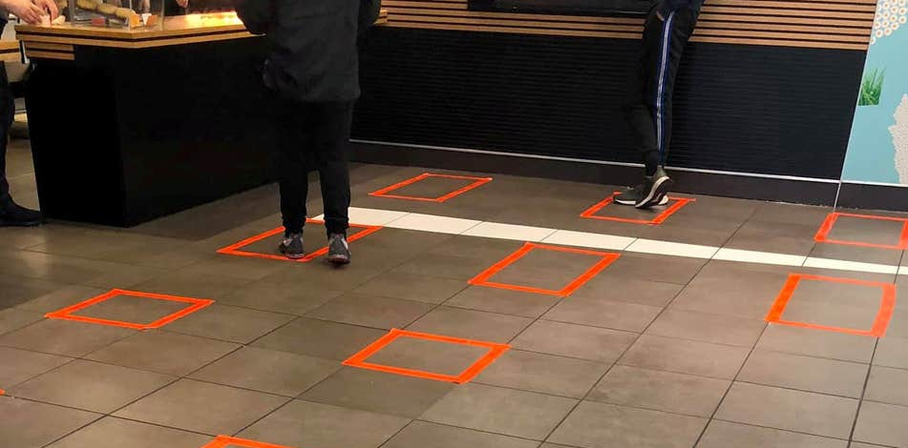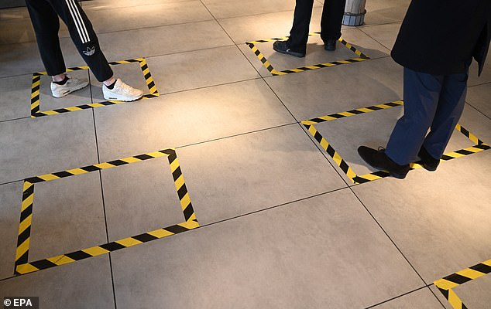  Customer waiting areas to be controlled, for example by demarcation of 2m square boxes  - Shopping centres to take responsibility for queuing in common areas.  - Clearly designate positions where staff can provide advice and assistance to customers whilst maintaining social distance.  - Work with local authorities and neighbouring businesses to spread number of customers arriving throughout the day by staggering opening hours.  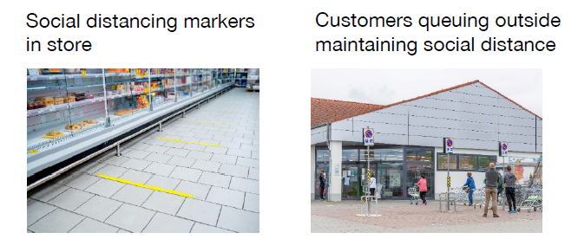  - Continue to keep customer cafes and restaurants closed until further notice. Unless providing a take-away service, with hot and cold foods to be consumed off the premises. Provide disposable cups, plates and cutlery.  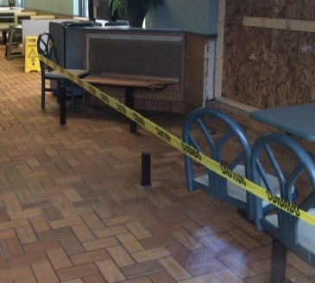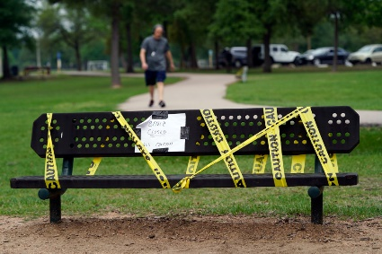  - Provide clear guidance on social distancing and hygiene to people on arrival, for example signage visual aids.  - Provide written or verbal communication of the guidelines to customers inside and outside of the store.  - Create social distancing champions to demonstrate social distancing guidelines  - Encourage customers to pre-order over the phone or internet with allocated time slots.  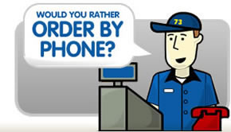  - Encourage payment by contactless and try not to handle cash as this may carry the virus.  - Pendle Council has produced posters to download and display inside and outside of your business.  - Inside poster  - Outside poster  - Posters are also available in Urdu and Bengali
This business will maintain 2 metre distances between people by:

Key Point 4 - Where people cannot be 2 metres apart, manage transmission risk
Employers should look into putting barriers in shared spaces, creating workplace shift patterns or fixed teams minimising the number of people in contact with one another, or ensuring colleagues are facing away from each other.
This business will manage transmission risk where people cannot be 2 metres apart by:

Key Point 5 - Reinforcing cleaning processes
Workplaces should be cleaned more frequently, paying close attention to high-contact objects like door handles and keyboards. Employers should provide hand washing facilities or hand sanitisers at entry and exit points.

Reinforcing cleaning processes - keeping the workplace clean

Keeping the workplace clean | Steps to be taken
Keep the workplace clean and prevent transmission by touching contaminated surfaces.  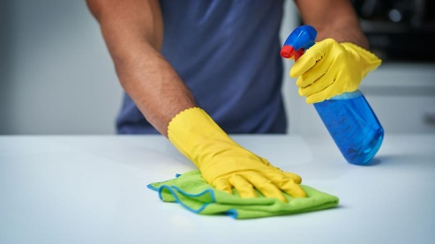 | - Frequent cleaning of work areas and equipment between uses.  - Frequent cleaning of objects and surfaces that are touched regularly including check outs, trolleys, coffee machines, betting machines or staff handheld devices and making sure that there are adequate disposal arrangements for cleaning products.  - Clear workspaces and removing waste and belongings from the work area at the end of the shift.  - If you are cleaning after a known or suspected case of COVID-19 then refer to specific guidance for cleaning after a known or suspected case of COVID-19  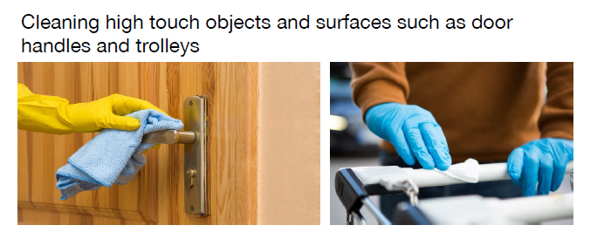  You may have become familiar with the code BS EN 1276 or BS EN 13697 that are discussed during your food hygiene inspections. Unfortunately, disinfectants that meet this standard do not guarantee protection from Covid-19.  Disinfectants that comply with the standard known as BS EN 14476 are the ones that will be effective against viruses within the “coronavirus” family.
The business is taking the following steps in keeping the workplace clean:

 | Reinforcing cleaning processes - hygiene, sanitation and toilets
Hygiene, hand washing, sanitation facilities and toilets | Steps to be taken
Help everyone keep good hygiene throughout the working day.  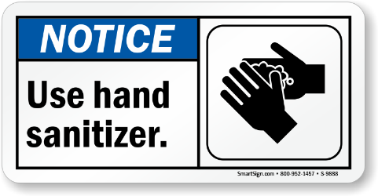 | - Use signs and posters to increase awareness of good hand washing techniques, the need to increase hand washing frequency, avoid touching your face, and to cough and sneeze into a tissue which is binned safely or into your arm if a tissue is not available.  - Provide hand sanitisers in multiple locations in additional washrooms.  - Set clear use and cleaning guidance for toilets to ensure that they are kept clean and social distancing is achieved.  - Enhanced cleaning to busy areas.  - Provide more waste facilities and more frequent rubbish collection.  - Provide hand drying facilities- either paper towels or electric dryers.  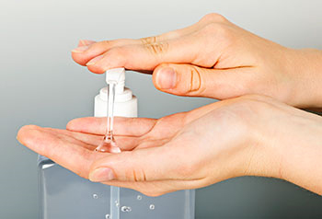
The business is taking the following steps to keep good hygiene throughout the day:

Customer fitting rooms

Customer fitting rooms | Steps to be taken
Minimise the risk of transmission through customer changing rooms. | - Fitting rooms should be closed wherever possible  - Where essential, for example to support key workers buying critical PPE, they shall be regularly cleaned, typically between each use.  - Create a procedure for clothes that have been tried on.  - Limit contact between customers and colleagues during fitting.
The business is taking the following steps to minimise the risk of transmission in customer fitting rooms:

 | Handling goods, merchandise and other materials
Handling goods, merchandise, and other materials | Steps to be taken
Reduce transmission through contacts with objects in store. | - Encourage increased hand washing and introduction of more hand washing facilities for workers and customers or providing hand sanitisers where this is not practical.  - Limit customers handling merchandise for example, through different display methods, new signage or rotation of high touch stock.  - Put into place picking-up, dropping-off collection points where possible, rather than passing goods hand to hand.  - Stagger collection times for customers collecting items, with a queuing system in place to ensure safe distance of 2m.  - Set up a no contact returns procedure where customers take returned goods to a designated area.  - Encourage contactless refunds where possible.  - Store items that have been returned, donated, brought in for repair or extensively handled for example shoes, clothing in a container or a separate room for 72 hours, or cleaning such items with usual cleaning products, before displaying them on the shop floor.  - Provide guidance to workers how they can safely assist customers when handling large items purchased.  - Consider placing protective coverings on large items that may require customer testing for example, furniture, beds or seats. Ensuring frequent cleaning of these coverings between uses, using usual cleaning products.  - Clean touch points after each customer use or handover. For example rental equipment, test drive and rental vehicles, interior and exterior touch points should be considered.
To reduce the risk of transmission of handling goods, merchandising and other materials, this business is taking the following steps:

 | PPE and face coverings
PPE and face coverings | Steps to be taken
Use of PPE and face covering | - The first and most crucial steps in preventing transmission of the infection is  - hand washing  - 2m social distancing  Other measures can enhance controls if they are of the right standard and used correctly  If you are wearing gloves to control the spread of infection, then be mindful to remove then once they have become contaminated – don’t move onto the next task without removing them/replacing them  - The evidence suggests that wearing a face covering does not protect you, but it may protect others if you are infected but have not developed symptoms.  - A face covering can be very simple and may be worn in enclosed spaces where social distancing isn’t possible, like in a small kitchen where applying the 2m rule may not be possible.  - A face covering just needs to cover your mouth and nose. It is not the same as a face mask, such as the surgical masks or respirators used by health and care workers. Similarly, face coverings are not the same as the personal protective equipment (PPE) used to manage risks like dust and spray in an industrial context.  - More information on how to wear a face covering, and how to make one is available on GOV.UK  - Wearing a face covering is optional and is not required by law, including in the workplace. If you choose to wear one, it is important to use face coverings properly and wash your hands before putting them on and taking them off. Employers should support their workers in using face coverings safely if they choose to wear one.  This means telling workers:  - Wash your hands thoroughly with soap and water for 20 seconds or use hand sanitiser before putting a face covering on, and after removing it.  - When wearing a face covering, avoid touching your face or face covering, as you could contaminate them with germs from your hands.  - Change your face covering if it becomes damp or if you’ve touched it.  - Continue to wash your hands regularly  - Change and wash your face covering daily.  - If the material is washable, wash in line with manufacturer’s instructions. If it’s not washable, dispose of it carefully in your usual waste.  - Practise social distancing wherever possible.
This businesses has chosen the following PPE and face coverings, for:

Shift patterns and working groups

Shift patterns and working groups | Steps to be taken
Change the way work is organised to create distinct groups and reduce the number of contact with each worker. | - As far as possible workers split into teams or shift groups. Fixing these shift groups so that where contact is unavoidable, this happens between the same persons.  - Identify areas where people have to directly pass things to each other and finding ways to remove direct contact using drop off points or transfer zones.
The following steps this business has taken to change work patterns and groups to reduce worker contact is:

 | Work related travel
Work related travel- cars, accommodation and visits | Steps to be taken
Avoid unnecessary travel and keep people safe when they do need to travel between locations | - Minimise non-essential travel  - Minimise the number of people travelling in one vehicle, using fixed travel partners, increasing ventilation and avoid sitting face to face.  - Clean shared vehicles between shifts or handover.  - Workers staying away from home centrally logging the stay and ensure accommodation meets social distancing guidelines.
This business has taken the following steps to keep people safe when they travel:

 | Deliveries to other sites
Deliveries to other sites | Steps to be taken
Help workers delivering to other sites such as factories, logistic sites or customer premises, to maintain social distancing | - Put into place procedures to minimise person to person contact during deliveries to other sites  - Maintain constant paring where two person deliveries are required.  - Minimise contact during payments and exchange of documentation, for example by using electronic payment methods and electronically signed documents.
To maintain social distancing of workers delivering to other sites, this business has taken the following steps:

Inbound and outbound goods
Inbound and outbound goods | Steps to be taken
Maintain social distancing and avoid surface transmission when goods enter and leave the site, especially in high volume situations e.g. distribution centres or despatch areas. | - Review and revise pick-up and drop off collection points, procedures, signage and markings.  - Minimise unnecessary contact at gatehouse security, yard and warehouse.  - Consider ways to reduce frequency of deliveries, e.g. by ordering large quantities less often.  - Where possible and safe, having single or same workers load or unload.  - Encourage drivers to stay in their vehicles
Thus business has taken will maintain social distancing and avoid transmission of goods by:

Risk Assessment
Steps that are needed from workplace guidance |  | How implemented. Any consultation? | Documentation (e.g. written instructions, notices for customers) | Management walk-around. Are the measures working? Are they being complied with by staff and customers? | Further measures following management check
Example- hazard tape on floor marking 2 m distance from checkouts for queuing customers |  | Discuss with employees and put down tape. | This risk assessment and verbal instructions. | No, some customers still too close. | Staff told to remind customers to socially distance. Laminated signs telling customers to stay behind the line.
After the risk assessment has been completed, what further regular monitoring will be carried out?

How will any further needed changes be put in place?

Finally save and upload your risk assessment onto your website as appropriate and print out and display the COVID-19 Secure notice
Employers should download and display a COVID-19 Secure notice in your workplace to show employees, customers and other visitors to their workplace that you have followed this guidance.
Download a COVID-19 Secure notice
